# cu.bmp

Data warehousing project

### **1- Cover page**

|  |  |
| --- | --- |
| Names | IDs |
| Farah Mohammed Hussien | 20210287 |
| Eslaam Sayed Gouda | 20211012 |

**Contents**

1

1- Cover page 1

2- Physical model of the source system: 5

3- Dimensional model 5

a- The business processes we modelled: 5

b- Grain of each fact table: 5

c- The type of each fact table: 5

d- The dimensions and the type of each one: 5

e- The measures that will appear in the fact tables 6

f- Physical model 6

4- Screenshots of the data flow tasks and control Flow. 7

1- Campaign dimension loading 7

a- Control flow 7

b- Data flow 7

1- From source to stage 7

2- Stage to destination 8

2- Customer dimension loading 8

a- Control flow 8

b- Data flow 9

1- From source to stage 9

2. Stage to destination 9

3- Product dimension loading 10

a- Control flow 10

b- Data flow 10

1- From source to stage 10

2- Stage to destination 11

4- Supplier dimension loading 11

a- Control flow 11

b- Data flow 12

1- From source to stage 12

2- Stage to destination 12

5- Sales Fact Table 13

a- Control flow 13

b- Data flow 13

1- From source to stage 13

2- From stage to destination 14

6- Sales Fact Table 14

A- Control flow 14

B- Data flow 15

1- From source to stage 15

2- From stage to destination 15

7- Sales Fact Table 16

A- Control flow 16

B- Data flow 16

1- From source to stage 16

2- From stage to destination 17

8- Batch file 17

5- Queries on each fact table and what insights we can get from it, and a screenshot of the result set of each query. 18

Sales Fact Table Queries 18

Total Sales for each country 18

Total Sales for each customer we can get customer name form customer dimension 19

Get number of orders for each customer 20

Get the total sales based on a date 21

Get total Sales for each marketing campaign 22

Total Sales For each payment_method 22

Retruns Fact Table Queries 23

Get amount Refunded for each customer 23

Get amount Refunded for a range of date 24

Get number of returns for a range of date 24

Get number of returns for each customer 25

Get number of returns for each product 26

Product Sales Fact Table Queries 27

Get Quantity sold for each product 27

Get Quantity sold for each supplier 28

Get Quantity sold for each subcategory 29

Get Quantity sold for each customer 30

Get total sales for each subcategory 31

Get total sales for each product 32

Get total sales for each supplier 33

6- Screenshots of the deployed packages in SSIS with their schedule 34

# 2- Physical model of the source system:

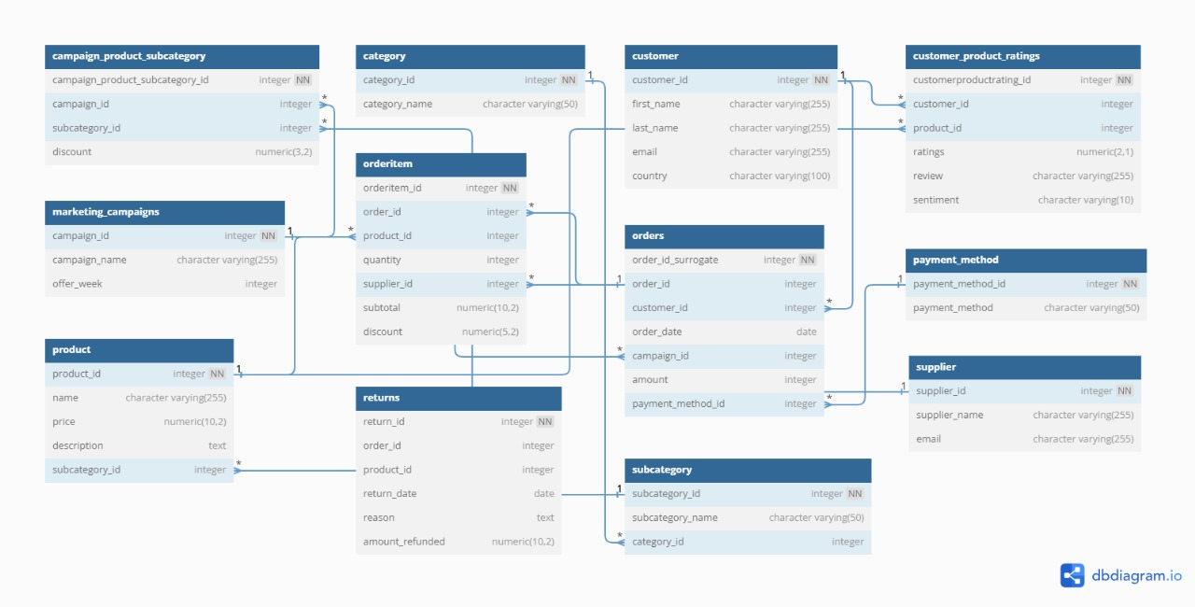

---------------------------------------------------------------------------------------------------------------------

# 3- Dimensional model

## The business processes we modelled:

The business process we modelled is an ecommerce website that makes marketing campaigns and discounts on holidays (New Year's, mother's day, etc.)

## Grain of each fact table:

1. Sales for each: Customer, Marketing campaign, country, order at a certain time
2. Returns for each : product, customer, review and a sentiment at a certain time
3. Quantity sold and sales for product: supplier, subcategory, customer

## The type of each fact table:

All tables are transactional Fact Tables

## The dimensions and the type of each one:

1. customer: Slowly changing confirmed dimension
2. country : Static degenerate dimension
3. Marketing campaign :static dimension
4. Product : slowly changing dimension
5. Subcategory: degenerate dimension
6. Supplier : slowly changing dimension
7. Payment Method: slowly changing dimension
8. DATE: confirmed dimension

## The measures that will appear in the fact tables

1. Sales _f Actual_cost : fully additive measure
2. Amount_refunded : fully additive measure
3. Quantity : semi additive measure
4. product_f Actual_cost : fully additive measure
5. rating : non-additive
6. sentiment: non additive

## Physical model

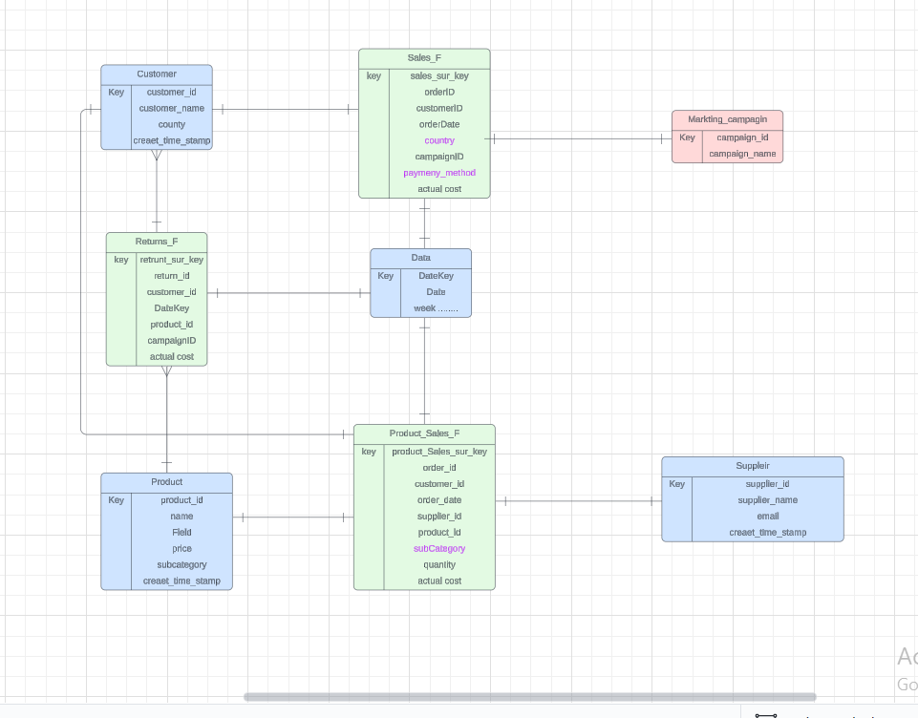

# 4- Screenshots of the data flow tasks and control Flow.

## Campaign dimension loading

### Control flow

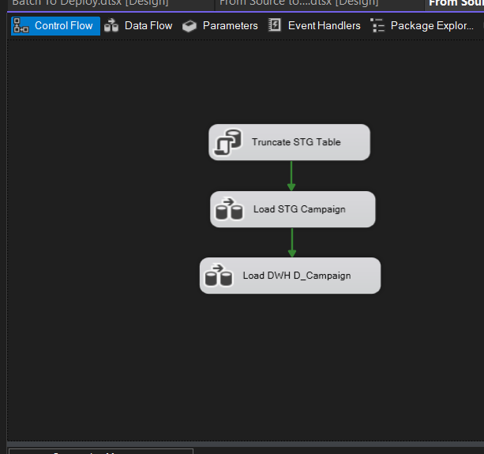

### Data flow

### From source to stage

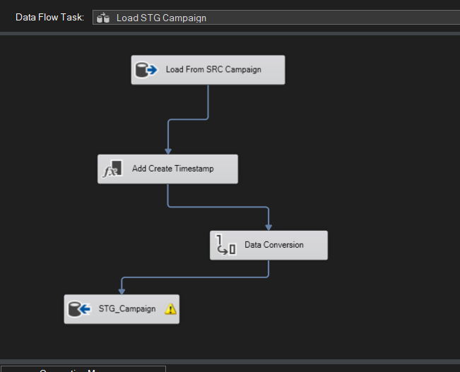

### Stage to destination

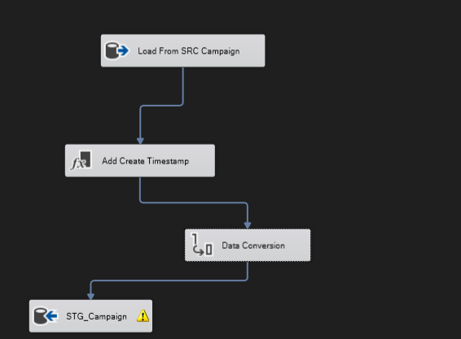

---------------------------------------------------------------------------------------------------

## Customer dimension loading

### Control flow

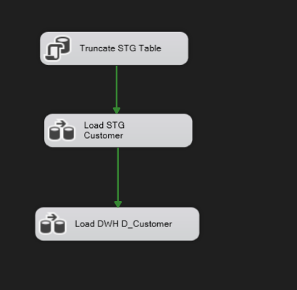

### Data flow

### From source to stage

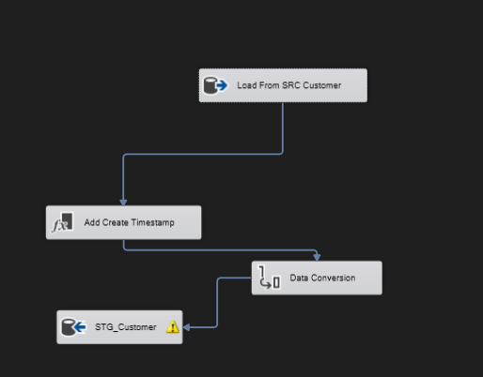

### 2. Stage to destination

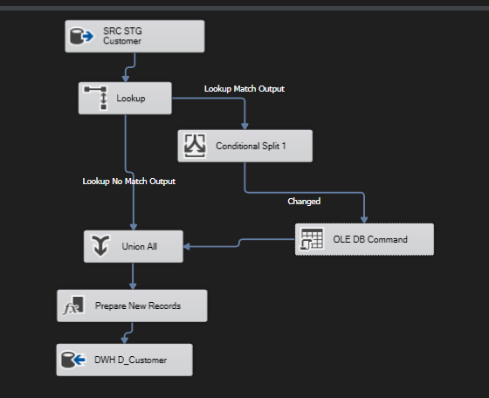

## Product dimension loading

### Control flow

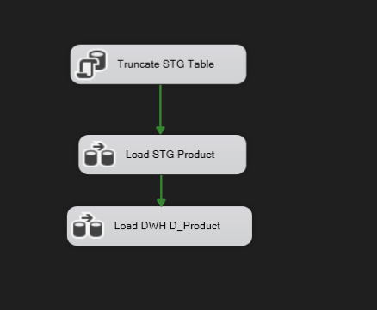

### Data flow

### From source to stage

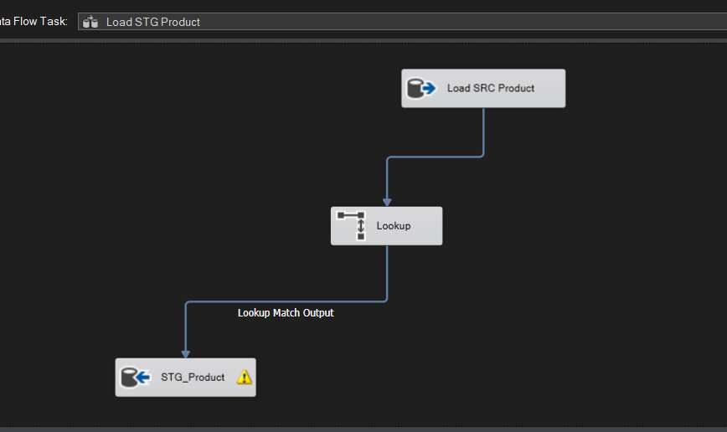

### Stage to destination

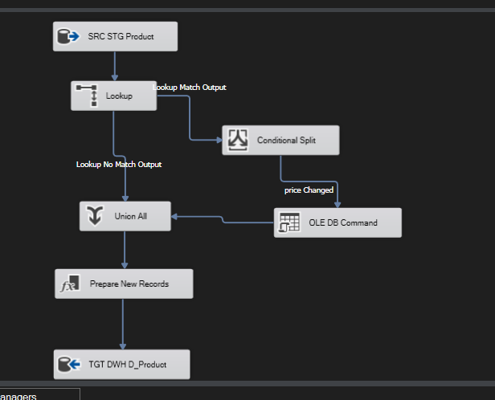

---------------------------------------------------------------------------------------------------------------------

## Supplier dimension loading

### Control flow

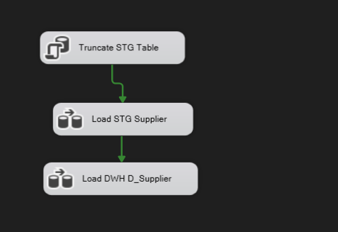

### Data flow

### From source to stage

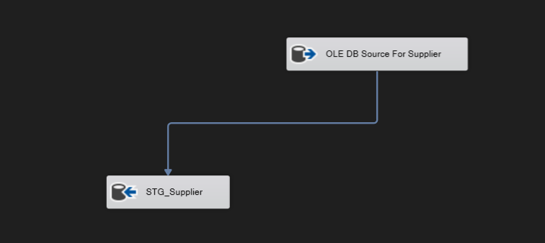

### Stage to destination

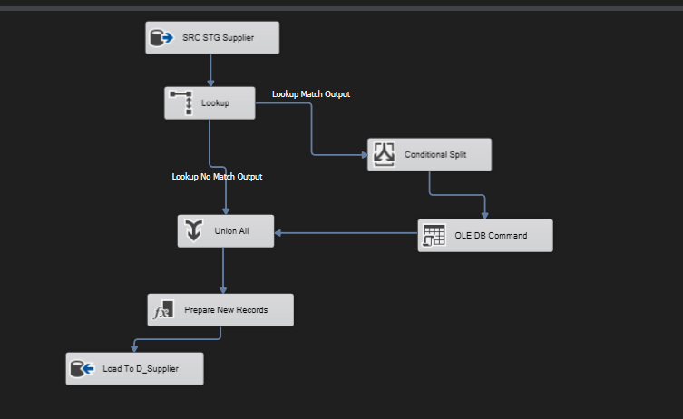

## Sales Fact Table

### Control flow

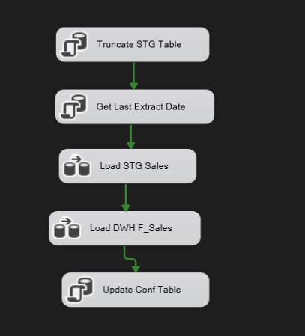

### Data flow

### From source to stage

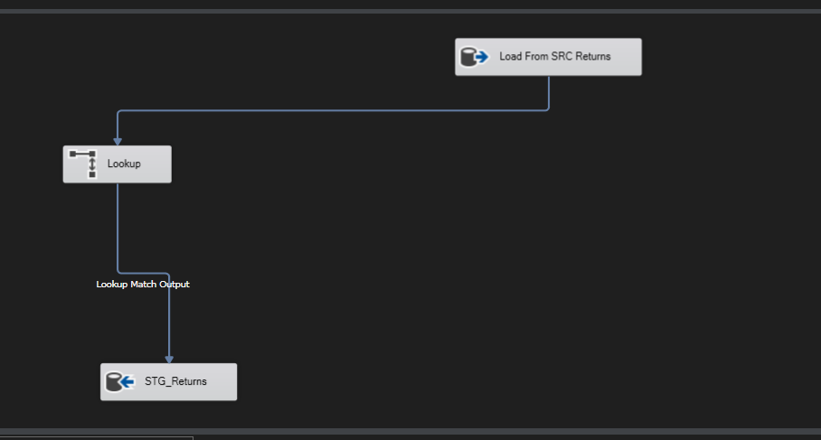

### From stage to destination

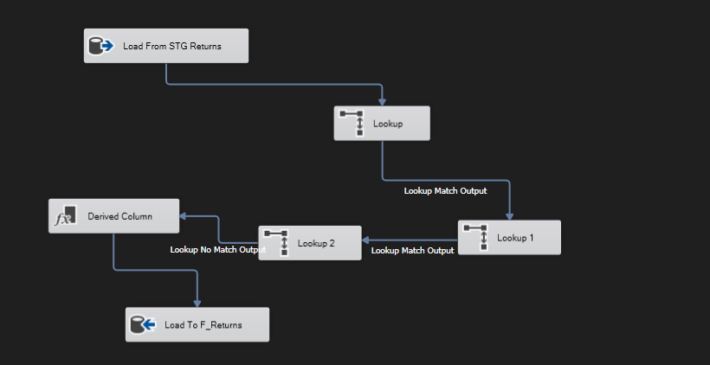

## Sales Fact Table

### Control flow



### Data flow

### From source to stage



### From stage to destination



## Sales Fact Table

### Control flow



### Data flow

### From source to stage



### From stage to destination



## Batch file

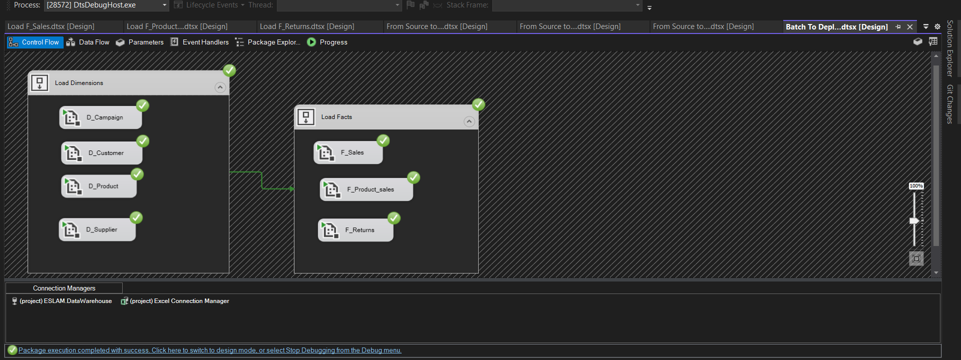

# 5- Queries on each fact table and what insights we can get from it, and a screenshot of the result set of each query.

## Sales Fact Table Queries

### Total Sales for each country

Select country, sum(actual_cost) as total from dwh.F_sales

Group by country

Order by country

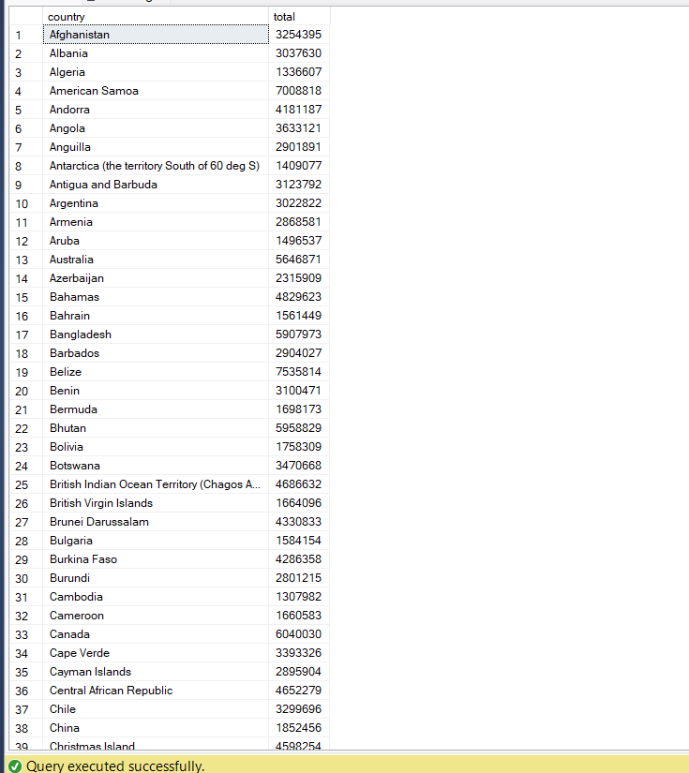

Total Sales for each customer we can get customer name form customer dimension

Select customer_id , sum(actual_cost) as total from dwh.F_sales

Group by customer_id

Order by customer_id

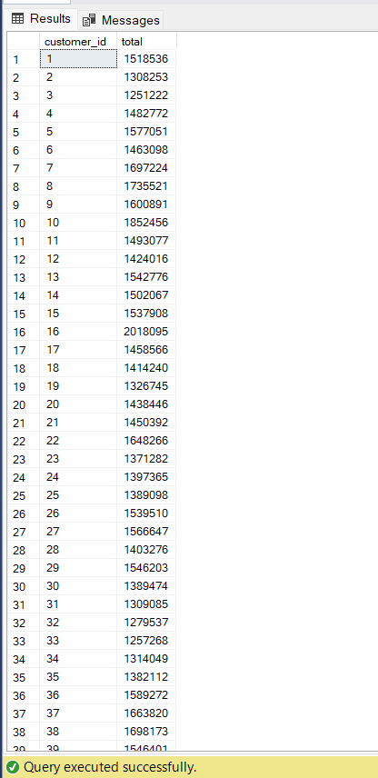

### Get number of orders for each customer

Select count(order_id) as number_of_orders , customer_id from dwh.F_sales

Group by customer_id

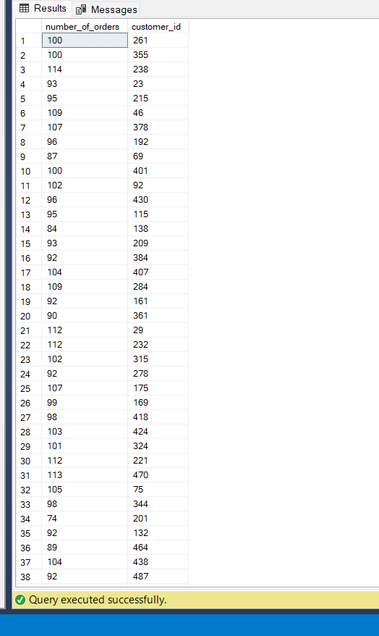

### Get the total sales based on a date

select sum(actual_cost) as total , datekey from dwh.F_sales

where datekey >= 20180101 and datekey < 20180201

group by datekey

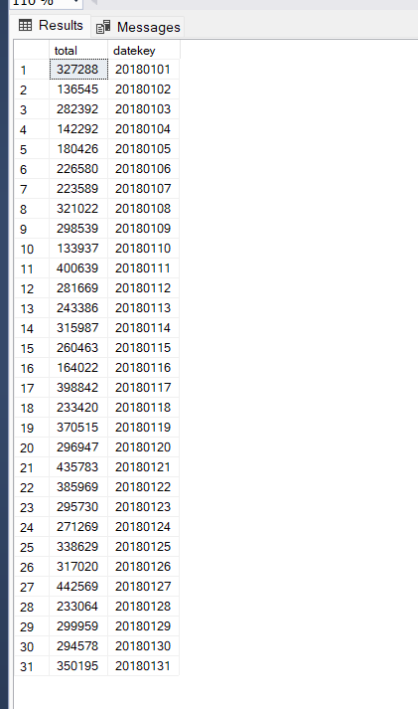

### Get total Sales for each marketing campaign

select campaign_id , sum(actual_cost) as total from dwh.F_sales

group by campaign_id

order by campaign_id

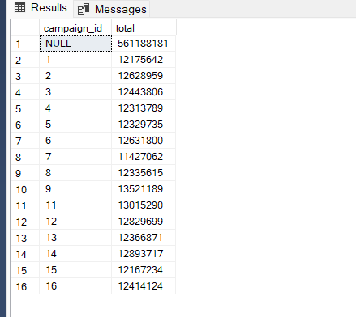

### Total Sales For each payment_method

select payment_method , sum(actual_cost) as total from dwh.F_sales

group by payment_method

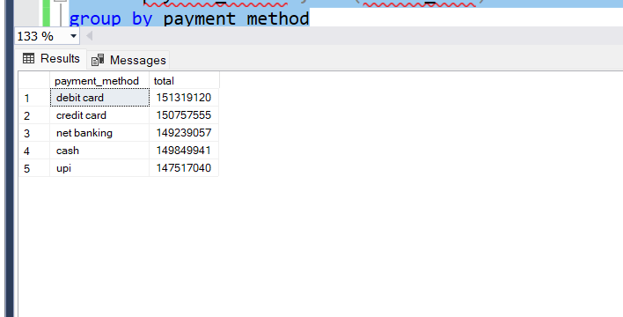

## Retruns Fact Table Queries

### Get amount Refunded for each customer

select sum(amount_refunded) as amount_refunded , customer_id from dwh.F_Returns

group by customer_id

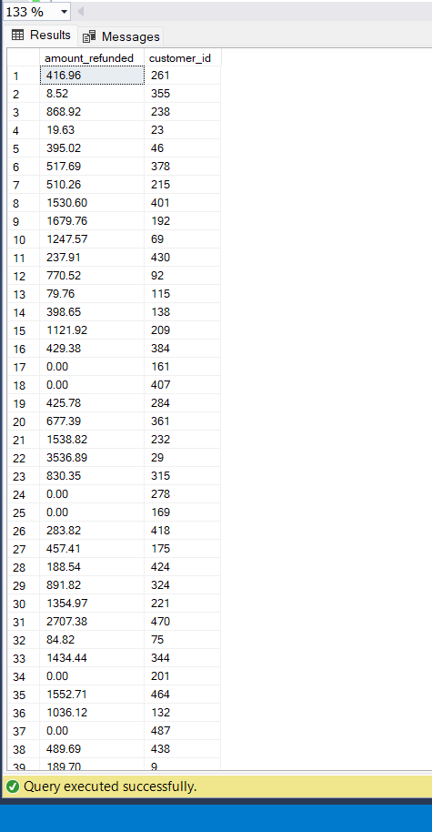

### Get amount Refunded for a range of date

select sum(amount_refunded) as amount_refunded , datekey from dwh.F_Returns

where datekey >= 20180101 and datekey <= 20180202

group by datekey

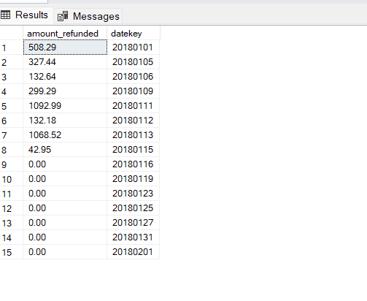

### Get number of returns for a range of date

select count(return_sur_key) as number_of_returns , datekey from dwh.F_Returns

where datekey >= 20180101 and datekey <= 20180202

group by datekey

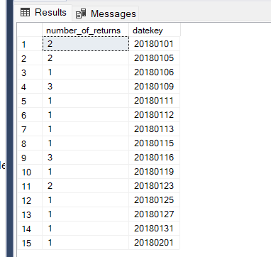

### Get number of returns for each customer

select count(return_sur_key) as number_of_returns , customer_id from dwh.F_Returns

group by customer_id

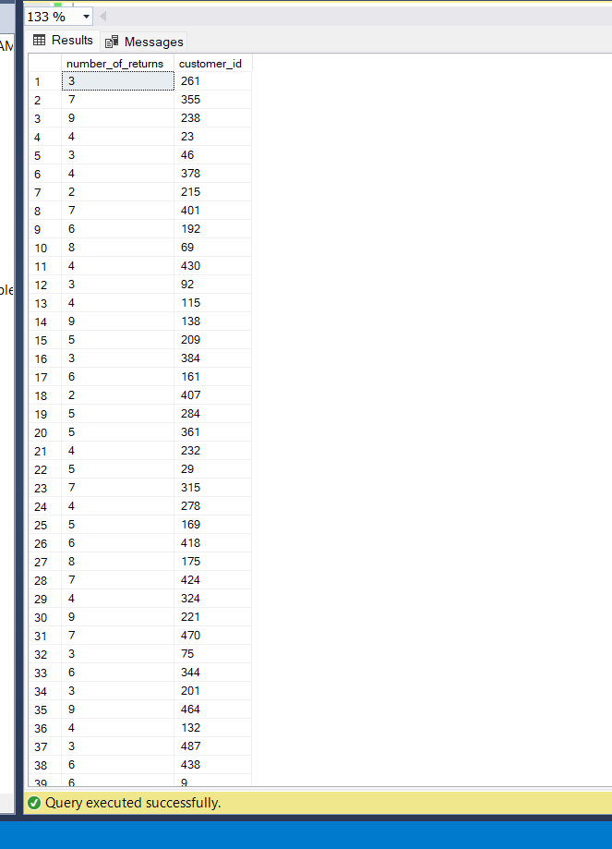

### Get number of returns for each product

select count(return_sur_key) as number_of_returns , product_id from dwh.F_Returns

group by product_id

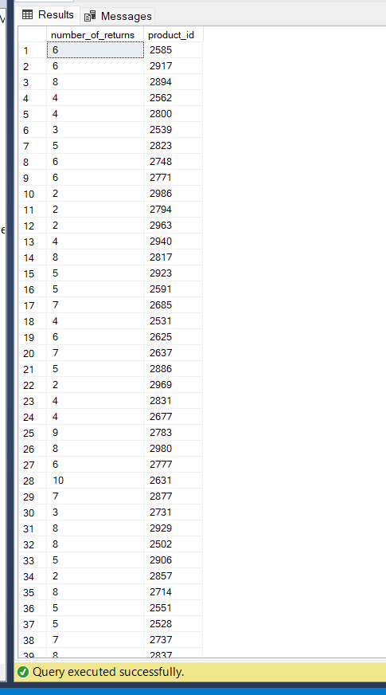

## Product Sales Fact Table Queries

### Get Quantity sold for each product

Select count(product_sales_sur_key) as number_of_sold , product_id from dwh.F_product_sales

Group by product_id

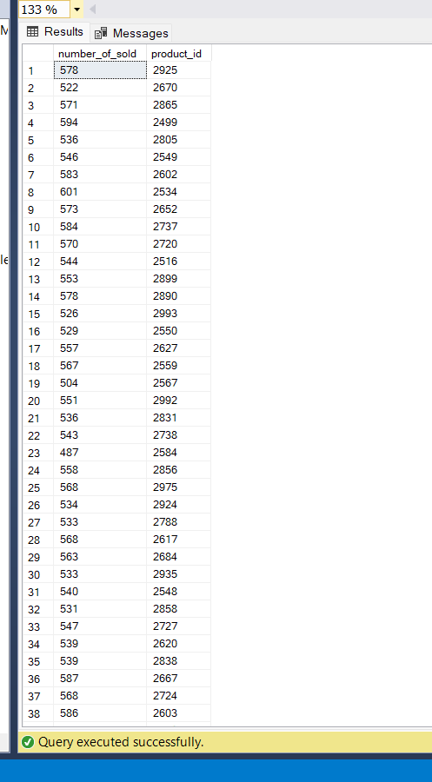

### Get Quantity sold for each supplier

Select count(product_sales_sur_key) as number_of_sold , supplier_id from dwh.F_product_sales

Group by supplier_id

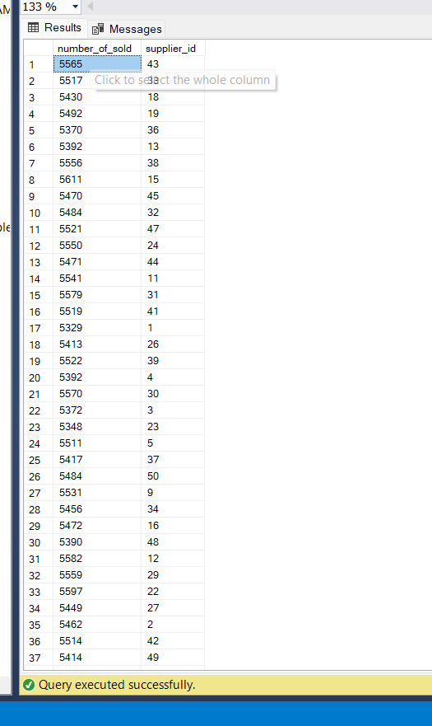

### Get Quantity sold for each subcategory

Select count(product_sales_sur_key) as number_of_sold , subcategory from dwh.F_product_sales

Group by subcategory

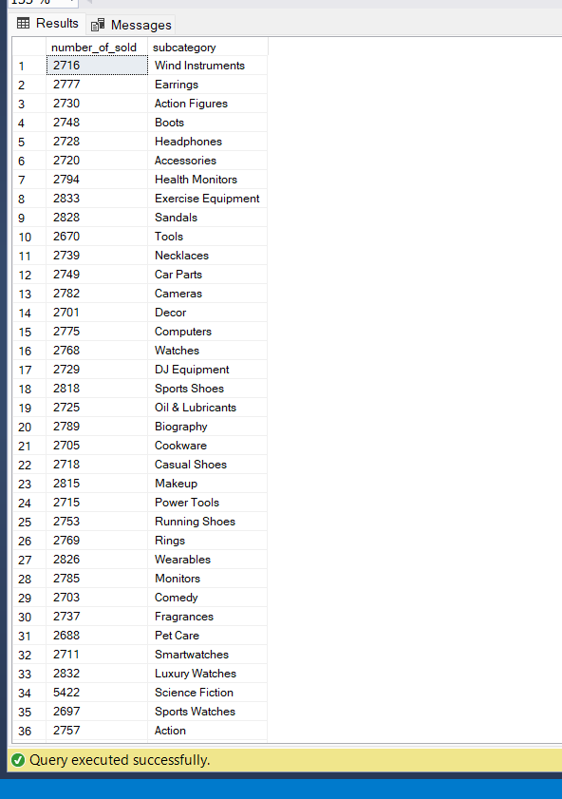

### Get Quantity sold for each customer

Select count(product_sales_sur_key) as number_of_sold , customer_id from dwh.F_product_sales

Group by customer_id

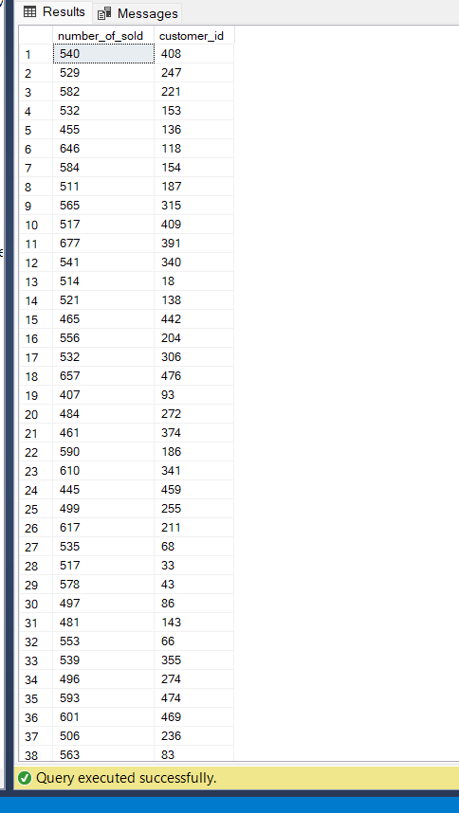

Get total sales for each subcategory

Select sum(actual_cost) as total_sales , subcategory from dwh.F_product_sales

Group by subcategory

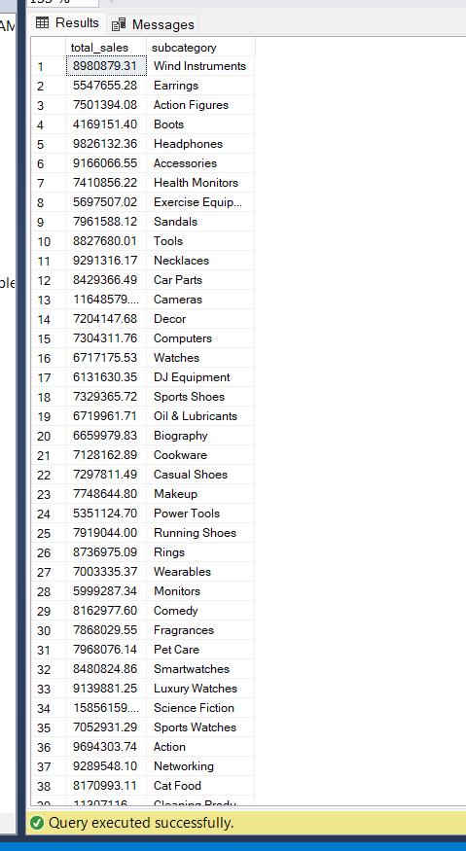

### Get total sales for each product

Select sum(actual_cost) as total_sales , product_id from dwh.F_product_sales

Group by product_id

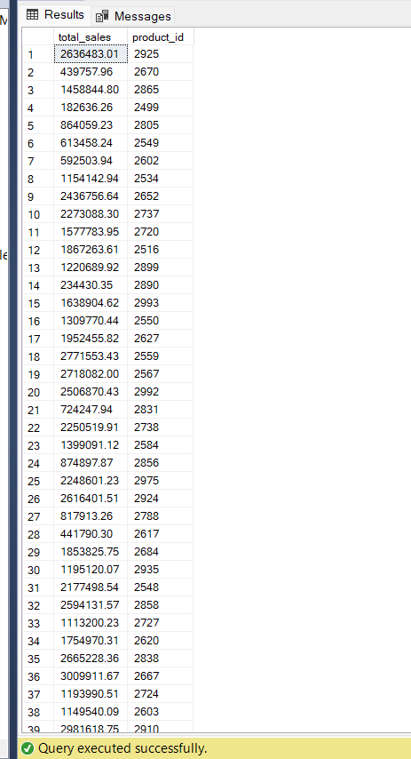

### Get total sales for each supplier

Select sum(actual_cost) as total_sales , supplier_id from dwh.F_product_sales

Group by supplier_id

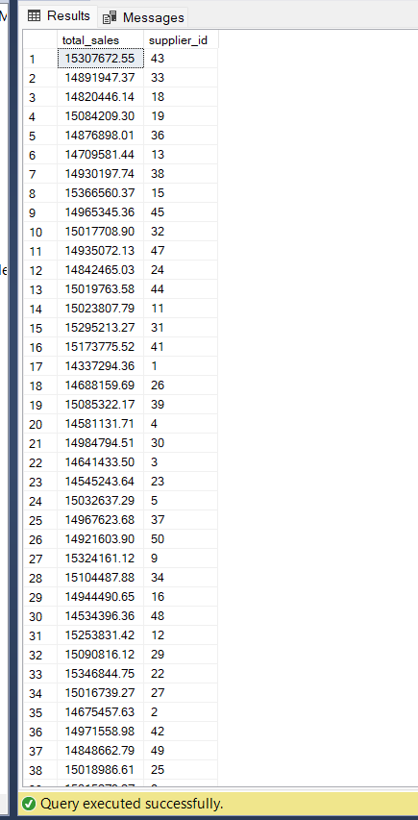

6- Screenshots of the deployed packages in SSIS with their schedule**.**

